Section 2

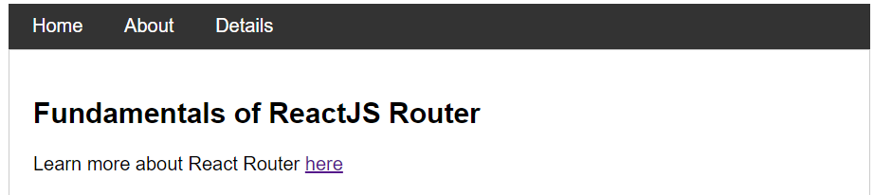

Section 3

Section 4

Section 5

Section 6

Section 7

Section 8

Section 9

